**PANDIT DEENDAYAL ENERGY UNIVERSITY**

**SCHOOL OF TECHNOLOGY**



**Course: System Software and Compiler Design Lab**

**Course Code: 20CP302P**

**LAB MANUAL**

**B.Tech. (Computer Science and Engineering)**

**Semester 5**

|  |  |  |
| --- | --- | --- |
|  | **Submitted By:** | |
|  | Harsh Shah |
|  | 21BCP359 |
|  | G11 batch |

|  |  |  |  |
| --- | --- | --- | --- |
| **Sr.**  **No.** | **Index** | | **Page No.** |
| **1** | Write C/C++ program to identify keywords, identifiers and others from the given input file. | | 2 |
| **2** | a.  b. | Write a LEX program to count the number of tokens and display each token with its length in the given statements.  Write a LEX program to identify keywords, identifiers, numbers and other characters and generate tokens for each. | 5 |
| **3** | a.  b. | Write a LEX program to eliminate comment lines (single line and multiline) in a high-level program and copy the comments in comments.txt file and copy the resulting program into a separate file input.c.  Write a LEX program to count the number of characters, words and lines in the given input.  Write a LEX program that read the numbers and add 3 to the numbers if the number is divisible by 7. | 9 |
| **4** | WAP to implement Recursive Decent Parser (RDP) parser for given grammar. | | 13 |
| **5** | Write a program to calculate first and follow of a given LL (1) grammar. | | 18 |
| **6** | WAP to construct operator precedence parsing table for the given grammar and check the validity of the string. | | 23 |
| **7** | 1. Write a YACC program for desktop calculator with ambiguous grammar (evaluate arithmetic expression involving operators: +, -, *, / and ↑). 2. Write a YACC program for desktop calculator with ambiguous grammar and additional information. 3. Design, develop and implement a YACC program to demonstrate Shift Reduce Parsing technique for the grammar rules:   E→ E + T | T  T→ T * F | F  F → P ↑ F | P  P → (E) | id  And parse the sentence: id + id * id. | | 26 |
| **9** | Implement menu driven program to execute any 2 code optimization techniques on given code. | | 32 |
| **10** | Select one block or expression from C language and generate symbol table and target code for the same. | | 34 |

**Experiment – 1**

**Aim:**

Write C/C++ program to identify keywords, identifiers and others from the given input file.

**Code:**

**Lab0.c**

#include <stdio.h>

int main(){

int a = 10, b = 20;

int sum = a + b;

printf("Sum = %d", sum);

return 0;

}

**Lab1.c**

#include <stdio.h>

#include <string.h>

#include <ctype.h>

#define MAX_IDENTIFIERS 100

const char* keywords[] = {

"auto", "break", "case", "char", "const", "continue", "default",

"do", "double", "else", "enum", "extern", "float", "for", "goto",

"if", "int", "long", "register", "return", "short", "signed", "sizeof",

"static", "struct", "switch", "typedef", "union", "unsigned", "void", "volatile", "while"

};

int is_keyword(const char* word) {

for (int i = 0; i < sizeof(keywords) / sizeof(keywords[0]); i++) {

if (strcmp(word, keywords[i]) == 0) {

return 1;

}

}

return 0;

}

int main() {

char identifier[MAX_IDENTIFIERS][50];

int numIdentifiers = 0;

FILE* file = fopen("Lab-0.c", "r");

char word[50];

while (fscanf(file, "%s", word) != EOF) {

if (is_keyword(word) == 1) {

printf("Keyword: %s\n", word);

} else if (isalpha(word[0])) {

int found = 0;

for (int i = 0; i < numIdentifiers; i++) {

if (strcmp(word, identifier[i]) == 0) {

found = 1;

break;

}

}

if (!found) {

strcpy(identifier[numIdentifiers], word);

printf("Identifier: %s\n", identifier[numIdentifiers]);

numIdentifiers++;

if (numIdentifiers == MAX_IDENTIFIERS) {

printf("Maximum number of identifiers reached.\n");

break;

}

}

}

}

fclose(file);

return 0;

}

**Output:**

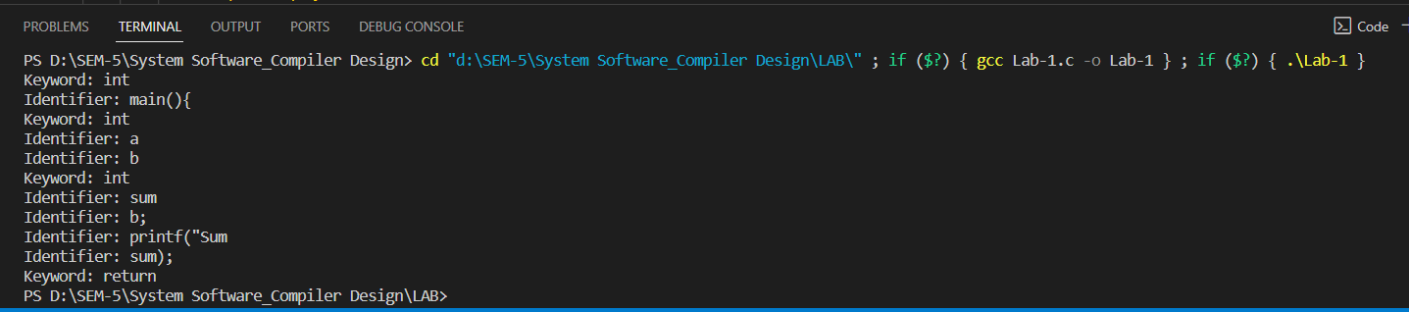

**Experiment – 2**

**Aim:**

1. Write a LEX program to count the number of tokens and display each token with its length in the given statements.
2. Write a LEX program to identify keywords, identifiers, numbers and other characters and generate tokens for each.

**Code:**

**Lab3.c**

#include <stdio.h>

int main() {

int a, b;

printf("Enter two numbers: ");

scanf("%d %d", &a, &b);

int sum = a + b;

printf("Sum: %d\n", sum);

return 0;

}

**a)**

%option noyywrap

%{

#include <stdio.h>

%}

%%

[a-zA-Z]+ { printf("Token: %s, Length: %d\n", yytext, yyleng); }

[0-9]+ { printf("Token: %s, Length: %d\n", yytext, yyleng); }

.|\n { printf("Ignoring: %s\n", yytext); }

%%

int main() {

yyin = fopen("Lab3.c", "r");

yylex();

return 0;

}

**b)**

%option noyywrap

%{

#include <stdio.h>

%}

%%

int|float|if|else|for|while|return { printf("Keyword: %s\n", yytext); }

[a-zA-Z][a-zA-Z0-9]* { printf("Identifier: %s\n", yytext); }

[0-9]+ { printf("Number: %s\n", yytext); }

.|\n { printf("Other: %s\n", yytext); }

%%

int main() {

yyin = fopen("Lab3.c", "r");

yylex();

return 0;

}

**Output:**

**a)**

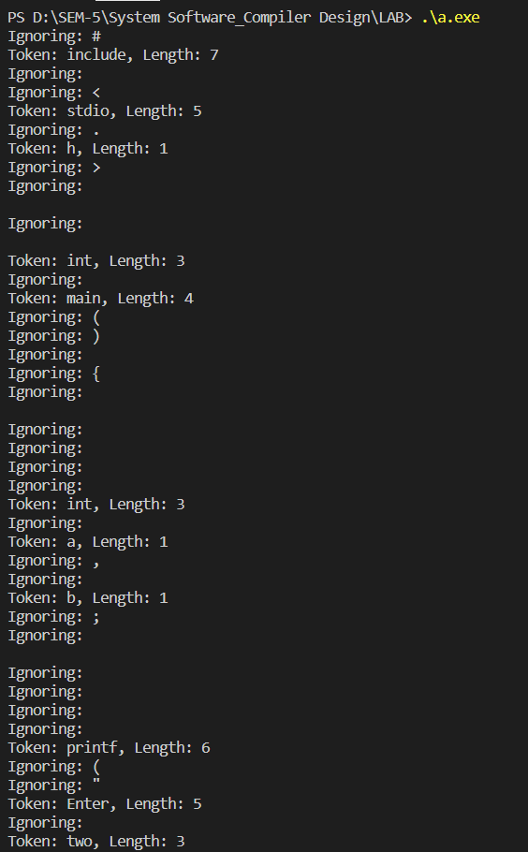

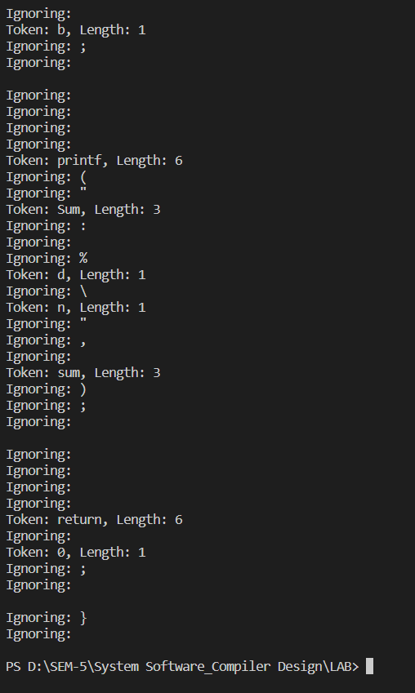

**b)**

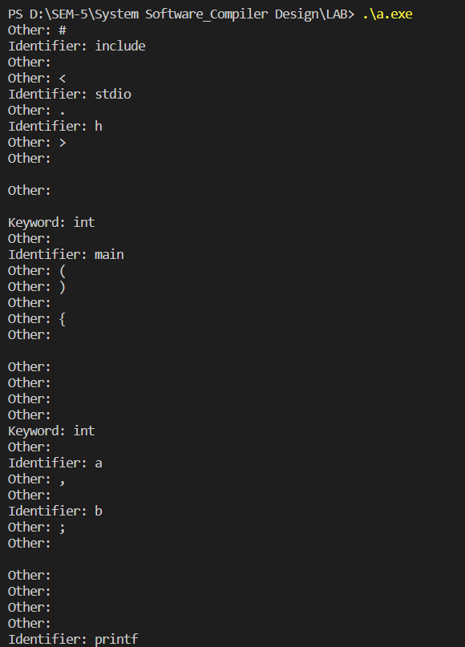 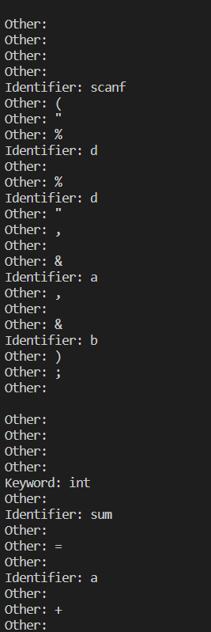 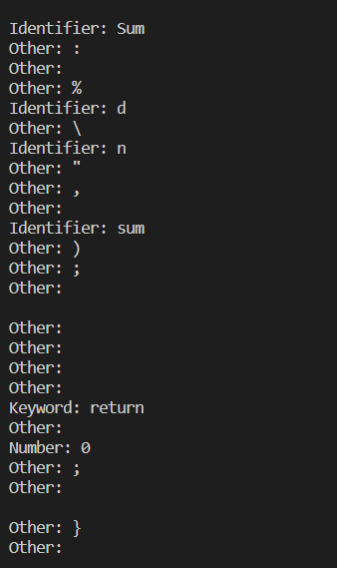

**Experiment – 3**

**Aim:**

1. Write a LEX program to eliminate comment lines (single line and multiline) in a high-level program and copy the comments in comments.txt file and copy the resulting program into a separate file input.c.
2. Write a LEX program to count the number of characters, words and lines in the given input.
3. Write a LEX program that read the numbers and add 3 to the numbers if the number is divisible by7.

**Code:**

**a)**

%option noyywrap

%{

#include <stdio.h>

%}

%option noyywrap

%%

"//"(.|\n)* { FILE *outFile = fopen("comments.txt", "a"); fprintf(outFile, "%s", yytext); fclose(outFile); }

.|\n { printf("%s", yytext); }

%%

int main() {

yyin = fopen("Lab3.c", "r");

yylex();

return 0;

}

**b)**

%option noyywrap

%{

#include <stdio.h>

int charCount = 0;

int wordCount = 0;

int lineCount = 0;

%}

%%

. { charCount++; }

\n { charCount++; lineCount++; }

[a-zA-Z]+ { wordCount++; }

%%

int main() {

yyin = fopen("Lab3.c", "r");

yylex();

printf("Character count: %d\n", charCount);

printf("Word count: %d\n", wordCount);

printf("Line count: %d\n", lineCount);

return 0;

}

**c)**

%option noyywrap

%{

#include <stdio.h>

%}

%%

[0-9]+ {

int num = atoi(yytext);

if (num % 7 == 0) {

num += 3;

}

printf("%d ", num);

}

.|\n { printf("%s", yytext); }

%%

int main() {

yyin = fopen("Lab3.c", "r");

yylex();

return 0;

}

**Output:**

**a)**

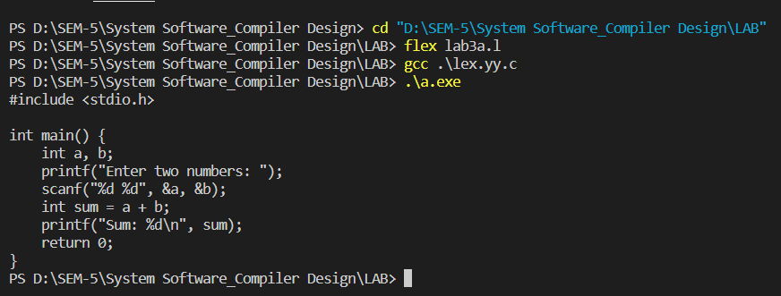

**b)**

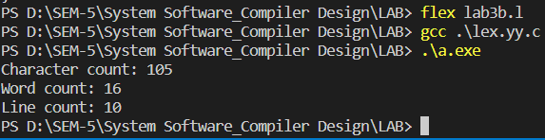

**c)**

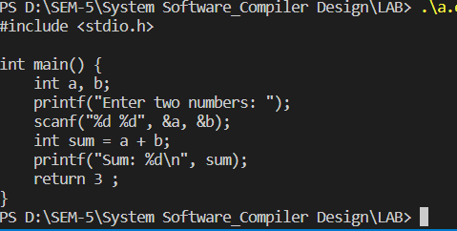

**Experiment – 4**

**Aim:**

WAP to implement Recursive Decent Parser (RDP) parser for given grammar.

**Code:**

#include <stdio.h>

#include <string.h>

#define SUCCESS 1

#define FAILED 0

// Function prototypes

int E(), Edash(), T(), Tdash(), F();

const char *cursor;

char string[64];

int main() {

puts("Enter the string");

scanf("%s", string); // Read input from the user

cursor = string;

puts("");

puts("Input Action");

puts("--------------------------------");

// Call the starting non-terminal E

if (E() && *cursor == '\0') { // If parsing is successful and the cursor has reached the end

puts("--------------------------------");

puts("String is successfully parsed");

return 0;

}

else {

puts("--------------------------------");

puts("Error in parsing String");

return 1;

}

}

// Grammar rule: E -> T E'

int E() {

printf("%-16s E -> T E'\n", cursor);

if (T()) { // Call non-terminal T

if (Edash()) // Call non-terminal E'

return SUCCESS;

else

return FAILED;

}

else

return FAILED;

}

// Grammar rule: E' -> + T E' | $

int Edash() {

if (*cursor == '+') {

printf("%-16s E' -> + T E'\n", cursor);

cursor++;

if (T()) { // Call non-terminal T

if (Edash()) // Call non-terminal E'

return SUCCESS;

else

return FAILED;

}

else

return FAILED;

}

else {

printf("%-16s E' -> $\n", cursor);

return SUCCESS;

}

}

// Grammar rule: T -> F T'

int T() {

printf("%-16s T -> F T'\n", cursor);

if (F()) { // Call non-terminal F

if (Tdash()) // Call non-terminal T'

return SUCCESS;

else

return FAILED;

}

else

return FAILED;

}

// Grammar rule: T' -> * F T' | $

int Tdash() {

if (cursor == '*') {

printf("%-16s T' -> * F T'\n", cursor);

cursor++;

if (F()) { // Call non-terminal F

if (Tdash()) // Call non-terminal T'

return SUCCESS;

else

return FAILED;

}

else

return FAILED;

}

else {

printf("%-16s T' -> $\n", cursor);

return SUCCESS;

}

}

// Grammar rule: F -> ( E ) | i

int F() {

if (*cursor == '(') {

printf("%-16s F -> ( E )\n", cursor);

cursor++;

if (E()) { // Call non-terminal E

if (*cursor == ')') {

cursor++;

return SUCCESS;

}

else

return FAILED;

}

else

return FAILED;

}

else if (*cursor == 'i') {

printf("%-16s F -> i\n", cursor);

cursor++;

return SUCCESS;

}

else

return FAILED;

}

**Output:**

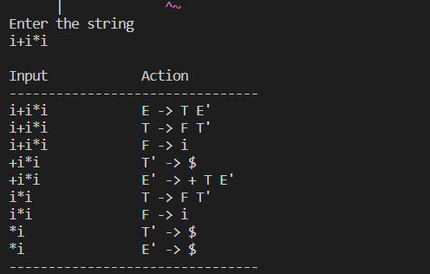

**Experiment – 5**

**Aim:**

Write a program to calculate first and follow of a given LL (1) grammar.

**Code:**

#include <stdio.h>

#include <stdbool.h>

#include <string.h>

#define MAX_SYMBOLS 10

char nonTerminals[] = "SAB";

char terminals[] = "ab";

char productions[][10] = {"S->aAb", "S->B", "A->a", "A->null", "B->b"};

bool isTerminal(char symbol) {

for (int i = 0; terminals[i]; i++) {

if (terminals[i] == symbol) {

return true;

}

}

return false;

}

void addToSet(char set[], char symbol) {

if (strchr(set, symbol) == NULL) {

strncat(set, &symbol, 1);

}

}

void calculateFirst(char nonTerminal, char first[]) {

for (int i = 0; productions[i][0]; i++) {

if (productions[i][0] == nonTerminal) {

int j = 3;

while (productions[i][j] != '\0') {

if (isTerminal(productions[i][j])) {

addToSet(first, productions[i][j]);

break;

}

else if (productions[i][j] != "null") {

calculateFirst(productions[i][j], first);

if (!strchr(first, "null")) {

break;

}

}

j++;

}

}

}

}

void calculateFollow(char nonTerminal, char follow[]) {

if (nonTerminal == 'S') {

// Start symbol

addToSet(follow, '$');

}

for (int i = 0; productions[i][0]; i++) {

for (int j = 3; productions[i][j]; j++) {

if (productions[i][j] == nonTerminal) {

int k = j + 1;

while (productions[i][k] != '\0') {

if (isTerminal(productions[i][k])) {

addToSet(follow, productions[i][k]);

break;

} else {

char first[MAX_SYMBOLS] = {0};

calculateFirst(productions[i][k], first);

bool epsilonFound = false;

for (int m = 0; first[m]; m++) {

if (first[m] == "null") {

epsilonFound = true;

} else {

addToSet(follow, first[m]);

}

}

if (!epsilonFound) {

break;

}

}

k++;

}

if (productions[i][k] == '\0') {

if (productions[i][0] != nonTerminal) {

calculateFollow(productions[i][0], follow);

}

}

}

}

}

}

int main() {

char first[MAX_SYMBOLS] = {0};

char follow[MAX_SYMBOLS] = {0};

for (int i = 0; nonTerminals[i]; i++) {

calculateFirst(nonTerminals[i], first);

}

for (int i = 0; nonTerminals[i]; i++) {

calculateFollow(nonTerminals[i], follow);

}

printf("\nFIRST sets:\n");

for (int i = 0; nonTerminals[i]; i++) {

printf("FIRST(%c) = {%s}\n", nonTerminals[i], first);

first[0] = '\0'; // Clear FIRST set for the next non-terminal

}

printf("\nFOLLOW sets:\n");

for (int i = 0; nonTerminals[i]; i++) {

printf("FOLLOW(%c) = {%s}\n", nonTerminals[i], follow);

follow[0] = '\0'; // Clear FOLLOW set for the next non-terminal

}

return 0;

}

**Output:**

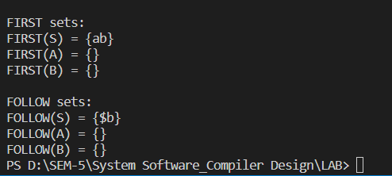

**Experiment – 6**

**Aim:**

WAP to construct operator precedence parsing table for the given grammar and check the WAP to construct operator precedence parsing table for the given grammar and check the validity of string.

**Code:**

from collections import defaultdict

# Example grammar

grammar = {

'E': ['E + T', 'T'],

'T': ['T * F', 'F'],

'F': ['( E )', 'id']

}

# Extract the set of terminals and non-terminals

terminals = set()

non_terminals = set()

for lhs, rhs in grammar.items():

non_terminals.add(lhs)

for symbols in rhs:

for symbol in symbols.split():

if symbol not in non_terminals:

terminals.add(symbol)

terminals.add('$')

# Initialize the table with empty cells

table = defaultdict(lambda: defaultdict(str))

for t1 in terminals:

for t2 in terminals:

table[t1][t2] = ''

# Fill in the table with precedence relations

for lhs, rhs in grammar.items():

for i in range(len(rhs)):

symbols = rhs[i].split()

for j in range(len(symbols) - 1):

left = symbols[j]

right = symbols[j + 1]

if right in non_terminals:

# Add all symbols that can follow the right symbol

for follow in terminals:

table[right][follow] += '<'

elif left in non_terminals:

# Add all symbols that can precede the left symbol

for precede in terminals:

table[precede][left] += '>'

elif left == '(' and right == ')':

# Parentheses have highest precedence

pass

else:

# Compare the precedence of the two adjacent symbols

table[left][right] += '=' if left == right == '+' or left == right == '*' else '<' if left == '+' or right == '*' else '>'

# Print the table

print(' ' * 4, end='')

for t in terminals:

print(f'{t:^4}', end='')

print()

for t1 in terminals:

print(f'{t1:^4}', end='')

for t2 in terminals:

print(f'{table[t1][t2]:^4}', end='')

print()

**Output:**

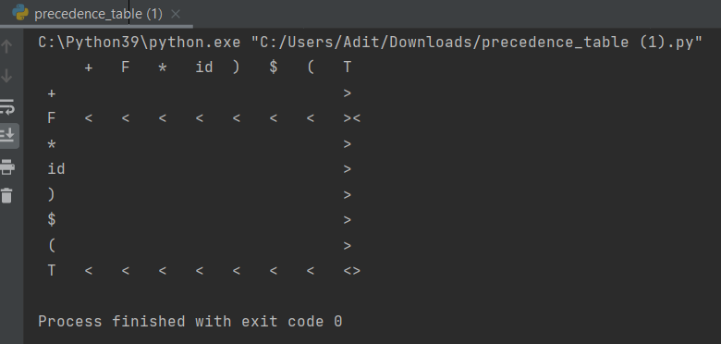

**Experiment – 7**

**Aim:**

1. Write a YACC program for desktop calculator with ambiguous grammar (evaluate arithmetic expression involving operators: +, -, *, / and ↑).
2. Write a YACC program for desktop calculator with ambiguous grammar and additional information.
3. Design, develop and implement a YACC program to demonstrate Shift Reduce Parsing technique for the grammar rules:
   1. E→ E + T | T
   2. T→ T * F | F
   3. F → P ↑ F | P
   4. P → (E) | id

And parse the sentence: id + id * id.

**Code:**

**a)**

**prog.y**

%{

#include<stdio.h>

%}

%token NAME NUMBER

%%

statement: NAME '=' expression

| expression {printf("= %d\n", $1);}

;

expression: expression '+' NUMBER {$$ = $1 + $3;}

| expression '-' NUMBER {$$ = $1 - $3;}

| expression '*' expression { $$ = $1 * $3; }

| expression '/' expression { $$ = $1 / $3; }

| NUMBER {$$ = $1;}

;

%%

void main(){ printf("\n Enter Expression: "); yyparse();

}

void yyerror(){ printf("\n Entered arithmetic Expression is Invalid\n\n");

}

**prog.l**

%{

#include "prog1.tab.h" #include<stdio.h> extern int yylval;

%}

%%

[0-9]+ {yylval = atoi(yytext); return NUMBER;}

[ \t]; /*Ignore white space*/

\n return 0; /*Logical EOF*/

. return yytext[0]; /*to not return any symbol to the parser*/

%%

int yywrap(){ return 1;

}

**b)**

**prog.y**

%{

#include <stdio.h>

%}

%token NAME NUMBER

%%

statement: NAME '=' expression

| expression { printf("Result: %d\n", $1); }

;

expression: expression '+' NUMBER { $$ = $1 + $3; }

| expression '-' NUMBER { $$ = $1 - $3; }

| expression '*' expression { $$ = $1 * $3; }

| expression '/' expression { $$ = $1 / $3; }

| '-' expression { $$ = - $2; }

| '(' expression ')' rest_of_expression { $$ = $2; }

| NUMBER { $$ = $1; }

;

rest_of_expression: '+' expression { $$ = $2; }

| '-' expression { $$ = -$2; }

| '*' expression { $$ = $2; }

| '/' expression { $$ = $2; }

| /* Empty production for no additional operator */

;

%%

int main(){ printf("\nEnter Expression: "); yyparse(); return 0;

}

void yyerror(const char *s){

printf("\nEntered arithmetic Expression is Invalid\n\n");

}

**prog.l**

%{

#include "prog4.tab.h" %}

%%

[ \t] ; // Skip whitespace

[0-9]+ { yylval = atoi(yytext); return NUMBER; }

[=] { return '='; }

[+] { return '+'; }

[-] { return '-'; }

[*] { return '*'; }

[/] { return '/'; }

[(] { return '('; }

[)] { return ')'; }

. { yyerror("Invalid character"); }

%%

int yywrap() { return 1;

}

**c)**

**prog.y**

%{

#include <stdio.h> %}

%token PLUS

%token T

%token END

%%

start: E END { printf("Valid Expression\n"); }

;

E: E PLUS T {

printf("Reduce: E -> E + T\n");

}

| T {

printf("Shift: E -> T\n");

}

;

%%

#include <stdio.h> #include <stdlib.h> int yylex(void);

int main() { printf("Shift-Reduce Parsing\n"); yyparse(); return 0;

}

void yyerror(const char *msg) {

fprintf(stderr, "Error: %s\n", msg);

}

**prog.l**

%{

#include "prog3.tab.h" %}

%%

[Tt] { return T; }

\+ { return PLUS; }

\n { return END; }

. { /* Ignore other characters */ }

%%

int yywrap() {

return 1;

}

**Output:**

**a)**

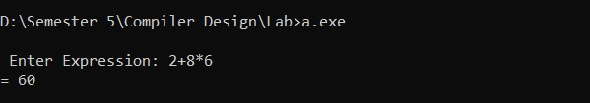

**b)**

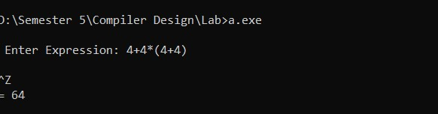

**c)**

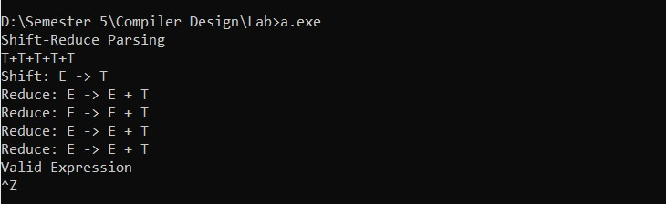

**Experiment – 9**

**Aim:**

Implement menu driven program to execute any 2 code optimization techniques on given code.

**Code:**

#include <stdio.h>

#include <string.h>

***// Function to perform Constant Folding optimization***

void constantFolding(char* code) {

char* optimizedCode = strstr(code, "5 + 3");

if (optimizedCode != NULL) {

strncpy(optimizedCode, "8", 1);

}

}

***// Function to perform Loop Unrolling optimization***

void loopUnrolling(char* code) {

char* optimizedCode = strstr(code, "for (int i = 0; i < 10; i++)");

if (optimizedCode != NULL) {

strncpy(optimizedCode, "int i = 0;\nwhile (i < 10) {", 29);

}

}

int main() {

char code[] = "int result = 0;\nfor (int i = 0; i < 10; i++) {\n result += 5 +

3;\n}\nprintf(\"Result: %d\\n\", result);\n";

int choice;

while (1) {

printf("Choose a code optimization technique:\n");

printf("1. Constant Folding\n");

printf("2. Loop Unrolling\n");

printf("3. Quit\n");

printf("Enter your choice (1/2/3): ");

scanf("%d", &choice);

if (choice == 1) {

constantFolding(code);

printf("Constant Folding applied.\n");

} else if (choice == 2) {

loopUnrolling(code);

printf("Loop Unrolling applied.\n");

} else if (choice == 3) {

break;

} else {

printf("Invalid choice. Please select 1, 2, or 3.\n");

}

}

printf("Optimized code:\n%s", code);

return 0;

}

**Output:**



**Experiment – 10**

**Aim:**

Select one block or expression from C language and generate symbol table and target code for the same.

**Code:**

int main() {

int a = 5;

int b = 10;

int c;

c = a + b;

return 0;

}

**Symbol Table Generation**

A symbol table is a data structure used by a compiler or interpreter where each identifier in a source program is stored along with information associated with its declaration or appearance in the source like its type, scope level, memory, location etc.

| **Identifier** | **Type** | **Scope** | **Memory Location** |
| --- | --- | --- | --- |
| main | Function | Global | - |
| a | int | main | Loc1 |
| b | int | main | Loc2 |
| c | int | main | Loc3 |

**Target Code Generation**

Target code generation is the phase in a compiler where source code is translated into machine code or an intermediate code. Let's assume we are generating pseudo assembly code for the above snippet.

_main:

; int a = 5;

MOV R1, 5 ; Move value 5 into register R1

STR R1, Loc1 ; Store the value from R1 into memory location Loc1 (a)

; int b = 10;

MOV R2, 10 ; Move value 10 into register R2

STR R2, Loc2 ; Store the value from R2 into memory location Loc2 (b)

; c = a + b;

LDR R3, Loc1 ; Load value from Loc1 (a) into register R3

LDR R4, Loc2 ; Load value from Loc2 (b) into register R4

ADD R3, R4 ; Add values in R3 and R4

STR R3, Loc3 ; Store result into Loc3 (c)

; return 0;

MOV R5, 0 ; Move 0 into R5 for return

RET ; Return from function

pseudo assembly code is a simplified representation of what target code might look like. It demonstrates the basic operations of moving data between registers and memory and performing an addition. In a real compiler, the target code will be much more complex and optimized, and it will be specific to the target machine's architecture.